Data Explorer
Traffic Lights Calculator version 2.0

Overview
Traffic Light Calculator is a simple rule-based tool to identify student behaviours that are often associated with a lack of engagement and risk of failing.
Student engagement is measured on three factors: Achievement, Physical Engagement and Virtual Activity (VLE etc).
Version 2.0 of Traffic Light Calculator, allows finer control of calculations.
Some key points
- The traffic light calculator is configured by the institutional site administrator supported by Jisc.
- Traffic light indicators are calculated for each active module a student is taking (it is not applied to completed modules).
- There are three calculations per module based on Achievement, Physical Engagement and Virtual Activity (VLE etc). This results in three traffic light indicators per module.
- Each student starts with 100 and based on the calculations lose points,
  - 100 pts = Green (filled circle)
  - 50-99 pts = Amber (half-filled circle)
  - 49 or lower = Red (unfilled circle)
  - Insufficient data = Gray
- The calculation parameters are institutional wide (at present until we learn more) but they can use module norms for activity.
- If enabled there is a separate predictive indicator which is pass probability at a course level which uses a predictive model (not explained here)
- The predictive model provides a predictor value of the student passing the course, either pass (green) or fail (red), with a percentage.
- The overall indicator can be created based on a combination of module traffic lights and predictor values.

Configuration
Once traffic light calculations are enabled by Jisc they will continue to run in the background and indicators will be stored in the learning data hub. At present you can only view the most recent indicators.
The setting in site admin configuration will switch on/off the indicators being visible in the tutor views.

Traffic Light Calculations set-up
- The TLC allows you configure what you see at the top-level indicators, these are the indicators that show in student lists as in the right here:
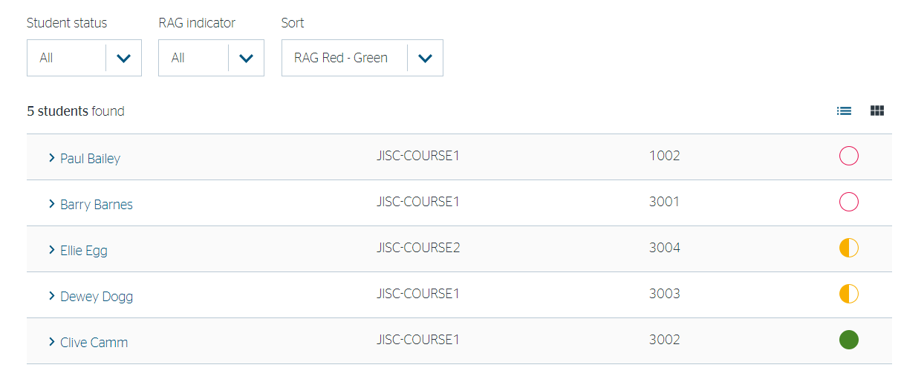
They are also the values used in the faculty, department and course overviews:
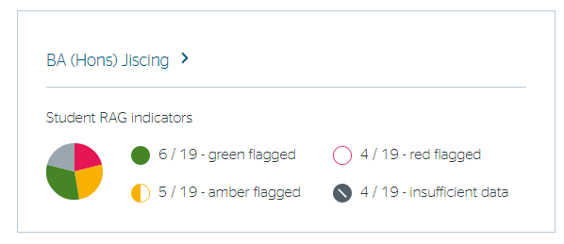
The faculty, department and course are a count of students with each risk associated with that group.

- Institutions can decide whether the top-level indicator is the predicator, the traffic light, or a combination.

- Institutions can decide how many ‘red’ or ‘amber’ module level indicators are needed to trigger a top-level indicator. The default is 1 but you could decide to make it more.

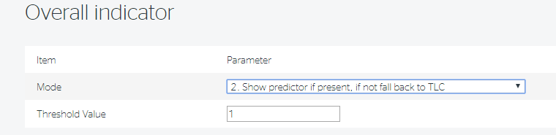
The options to set the top-level indicator are
- Only show predictor value – (See below)
- Show predictor if present, if not fall back to TLC – Mode 1 if predictor if not use mode 5
- Combine – Module TLC count or Predictor to trigger a red or amber - (see below)
- Combine – Add Predictor value to TLC colour counts - so just treat predictor as another traffic light
- Base on TLC only – (see below)
The rules for the combining options are as follows:
Under options 3 the following rules apply:
Show red if: predictor = fail value OR count Red TLCs >= threshold value
Show amber if: predictor = pass AND count Red TLCs < threshold value AND count Amber TLCs >=threshold value
Show green if: predictor = pass and Count Amber TLCS < threshold value AND Count Red TLCS < threshold value
Under options 2 and 5 the following rules apply:
Show red if: count Red TLCs >= threshold value
Show amber if: count Red TLCs < threshold value AND count Amber TLCs >= threshold value
Show green if: count Amber TLCS < threshold value AND count Red TLCS < threshold value

- Institutions can configure the parameters for the virtual and physical engagement and define how many days data to take into account for the calculations for Virtual (VLE) and Physical (Attendance) engagement. This was previous set to 30 days.

There are three parameters
- Days since last VLE activity – will be triggered if no activity for days set, with the points set deducted from the total
- Days since last VLE activity (extended risk) – will be triggered if no activity for a longer period of days set
- VLE usage % less than module average – will be triggered if students VLE activity is set percentage less than average.
NB The days since last are based on total student activity not by module.
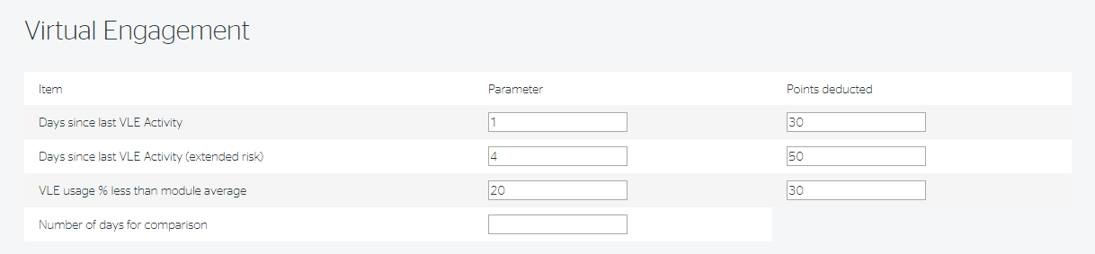

Similar for physical engagement

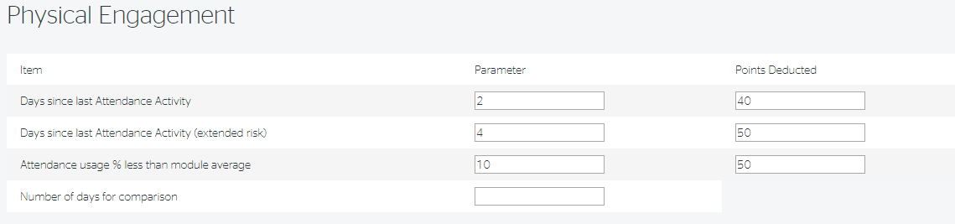

- Institutions can configure the parameters for achievement based on average marks for a module. Points are deducted based on “parameter 1 <= average mark < parameter 2”. Institutions can also set a parameter for the number of retakes on module to trigger a deduction of points.

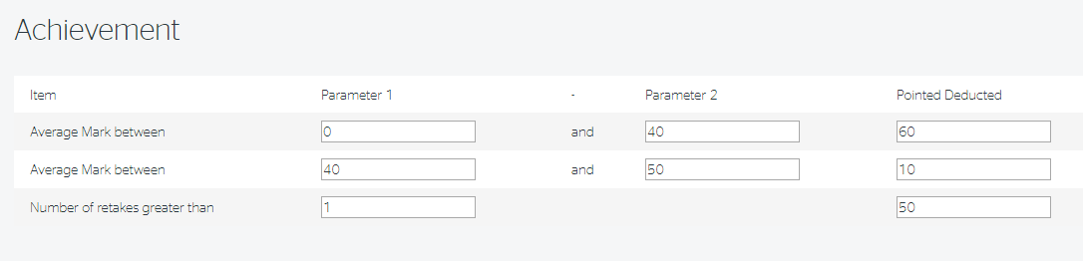

Configuring and Fine Tuning the Traffic Light Calculations
Jisc will help institutions to configure the traffic light calculations to make the most of your data.

Edge case rules
How we handle some edge cases
- Modules with very low VLE activity – defined as less an average of less than 5 events over the “Number of days for comparison” will show a Grey indicator.
- Modules with very low attendance activity – defined as …How we treat it..
- Modules assignments marks where there is no data in the ASSESS_xxx_MARK will show a Grey indicator. This may be the case where only a grade is given.
- Modules with less than x students will not calculate a risk for VLE or Attendance usage % less than average as the size is too small to have a valid average.
- Courses with all grey indicators or low numbers….

What we have learnt so far/suggest you do
- Jisc will help you configure an initial set of parameters based on analysis of your data.
- The configuration will depend on the type of student support and interventions approach you are taking for example you might want to optimise to
  - Allow tutors to see students who have any risk indications, so they can make timely interventions
  - Identify the most at risk students at high level e.g. across a course or department
  - A compromise between the two, until you can get a manageable number of students at risk
- Run the calculations in pioneer version first to get an idea of how it will look. Use the department and course view to see the proportion of students at risk.
- This is also an opportunity to try and identify any data issues such students on modules with no VLE mapping (this maybe data issue or that a course/module does not have a VLE module).
- Then transfer to stable and enable TLC in site admin configurations so tutors can see them. Ask the tutors to review and report any anomalies. In time we will be able to allow for some of these but never all.
- Remember that although the configuration is global, the calculations are at module level and compare to module averages. Also the edge case rules above will sift out modules where there is limited VLE engagement.
- At the start of the year there will less activity data to make calculations, but this should adjust itself with a couple of weeks also unlikely to be any assignments.
- At the end of the year, over holidays there will be periods of reduced activity. Consider increasing the number of days for comparison.

Providing Feedback or Reporting Faults
If you find a problem with the software or the data then you should contact your institutional project lead who will collate and report to c via our helpdesk.

