Data Explorer
Tutor Guide version 2.0.2

Overview
Data Explorer is a dashboard interface to allow institutions to view student information as part of the Jisc learning analytics service.
Currently the learning data hub contains information on current students, their modules and assignments (marks). Engagement activity is based on their use of online (VLE) and attendance.

Getting Started
Data Explorer works best in Chrome and is being tested with IE, Safari and Firefox.
To access Data Explorer https://datax.jisc.ac.uk/
The login uses your institutional authentication page, select your institution to login.
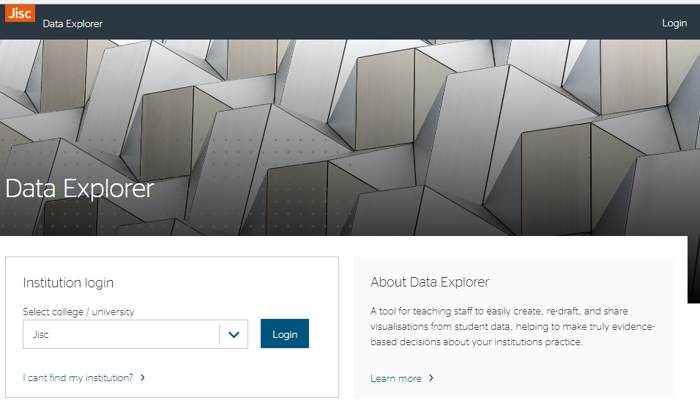

Tutor View
Once you have logged into Data Explorer you will see the following Icons.
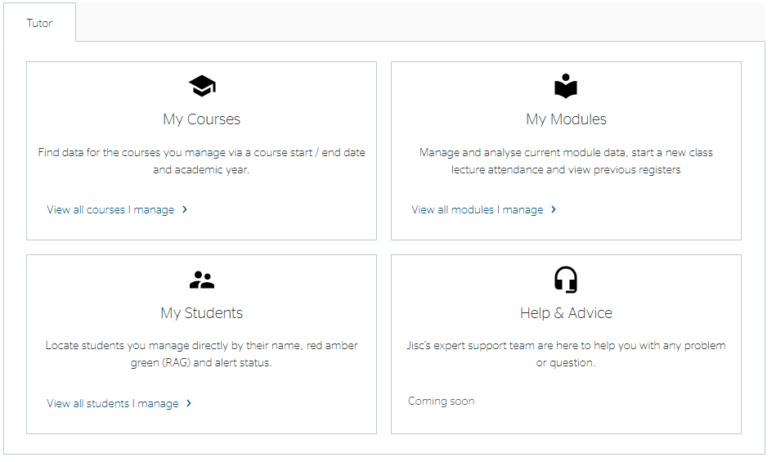

My Courses
If you select ‘My Courses’ you will be able to see a list of all the courses you teach.
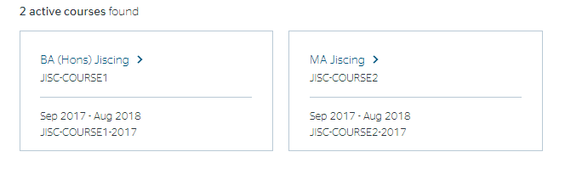

My Students
If you select ‘My Students’ you will be able to see a list of all your tutees.
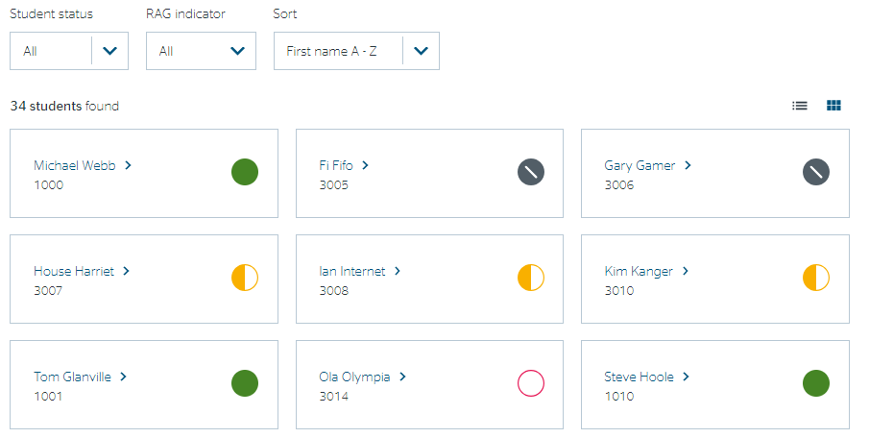
The indicator shows the students risk status and the list can be sorted. Where the Traffic Light Calculator cannot make an assessment, due to lack of data, the indicator on Student Search will be coloured grey.
The list can be sorted by name, student ID or risk indicator and filter by student status or risk (RAG) indicator.

Clicking on the student name will allow you to see data on an individual student. There are several tabs which allow you to view
- Course data overview – showing overall data and indicators
- Module traffic lights – show the RAG indicators for each module
- Module data – showing activity data and assessment for each module
- Notes (optional) – allows recording of notes on student interactions
- Bio -provides other information about the student
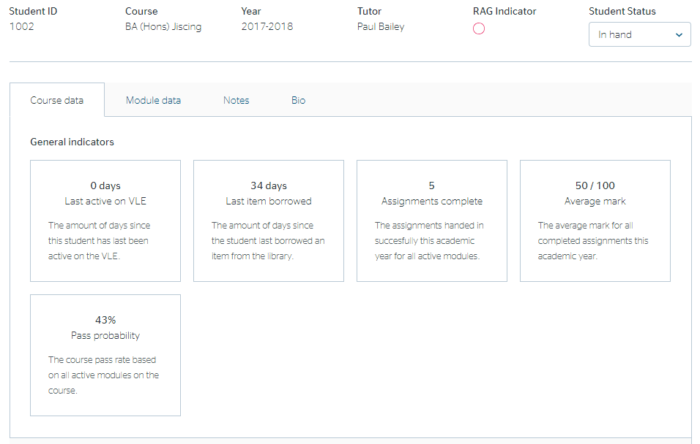

You will also see some general indicators for the student overall. The pass probability is the outcome from the predictive model (if available).

Course Data
The following visualisations are available
- Attendance
- VLE Activity
- Activity with Assessment
- Assessments over time
- Last item borrowed
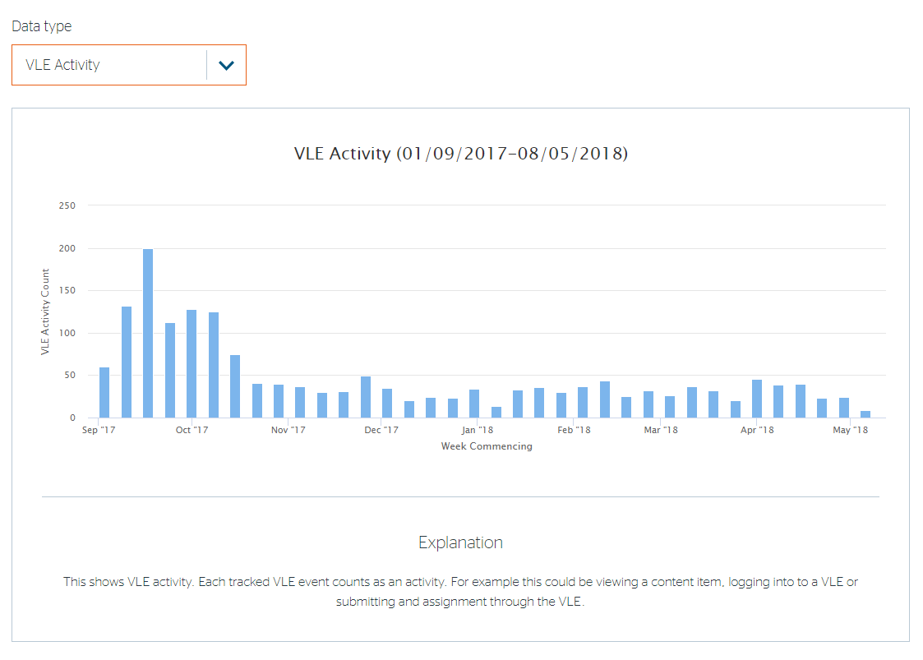
An explanation is provided on each screen to explain what is on view.
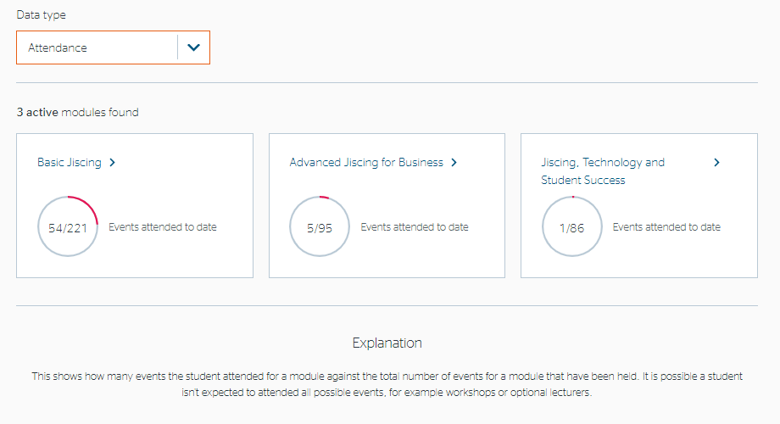

The above example takes information from events created in Study Goal. However, information from institutions own attendance systems can also be displayed.

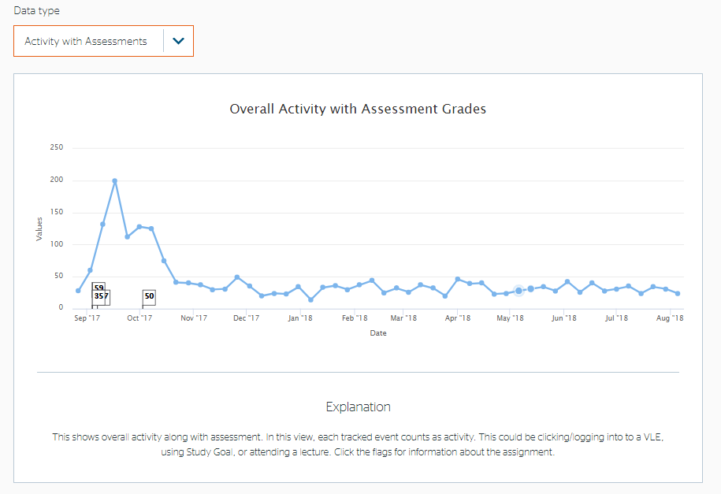
Click on the flags in the “Overall activity with assessment grades” graph or the nodes in the “Assessment over time” graph to obtain more detail about the assessment.
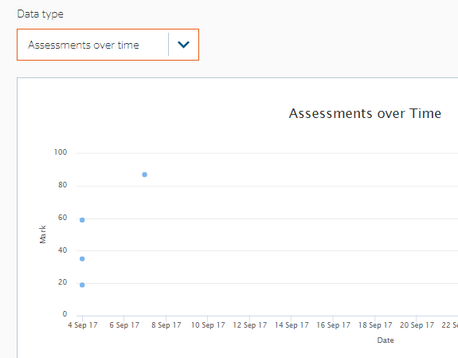
Clicking on these points will display a pop-up:

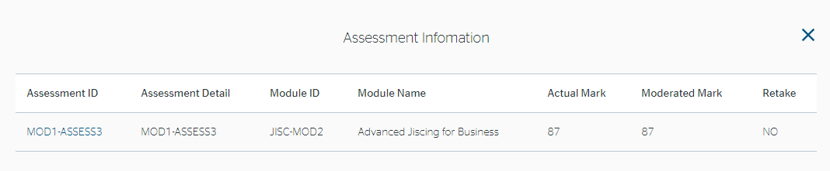

At the bottom of the page you will see ‘module traffic lights’ which provides a RAG rating for each measure of activity including VLE usage, marks and attendance.
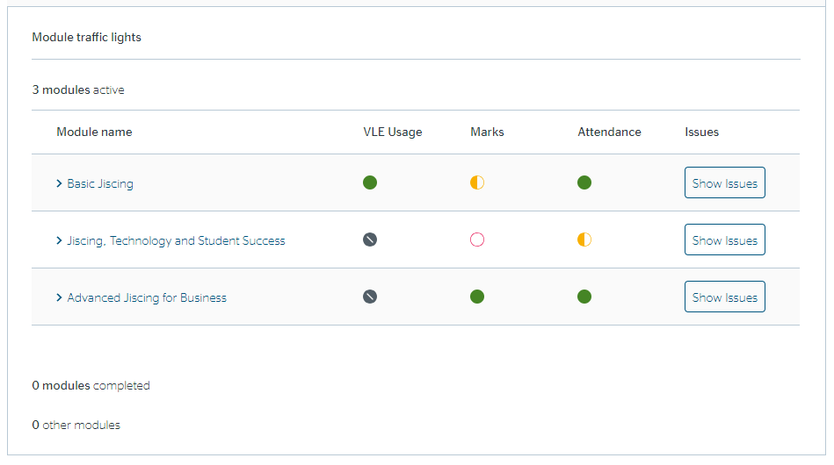
Clicking on the ‘show issues’ button will show why the issue was triggered.
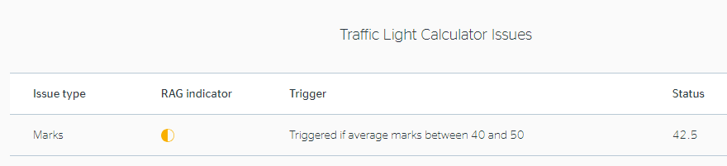

Module Data
You can also view student data by module. Clicking on the ‘Module data’ tab allows viewing of the indicators for each module. You can select the different modules from the drop-down menu and you can also select which ‘Data type’ you want to use
- General indicators – the number of completed assignments and average mark
- Assessment breakdown – assignments associated with this module and marks/grades if submitted
- Overall Activity – provides a graph of engagement activity by month and average for that module

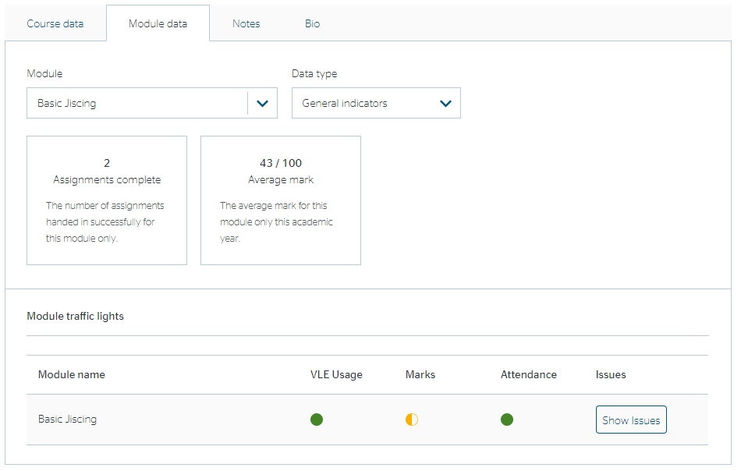
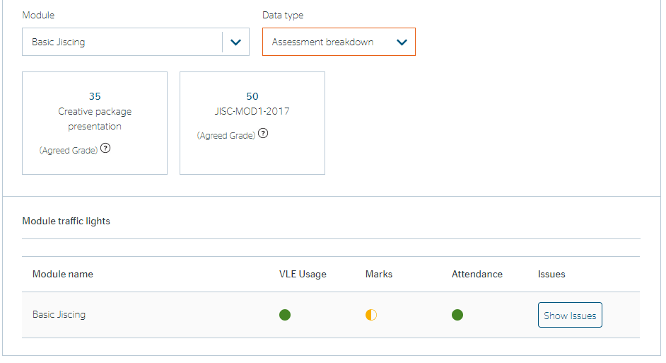
By clicking on the grade of assessment, you will see a graph of the assessment mark distribution.
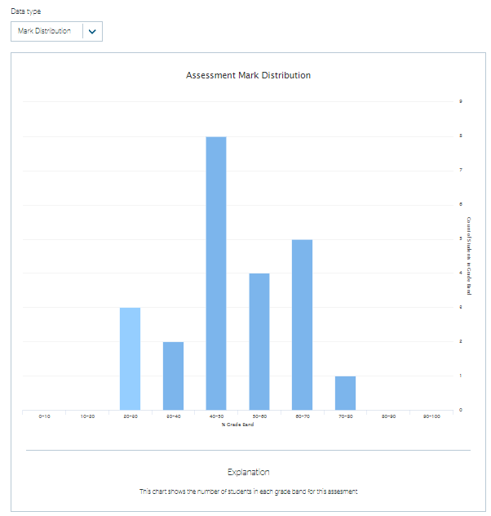
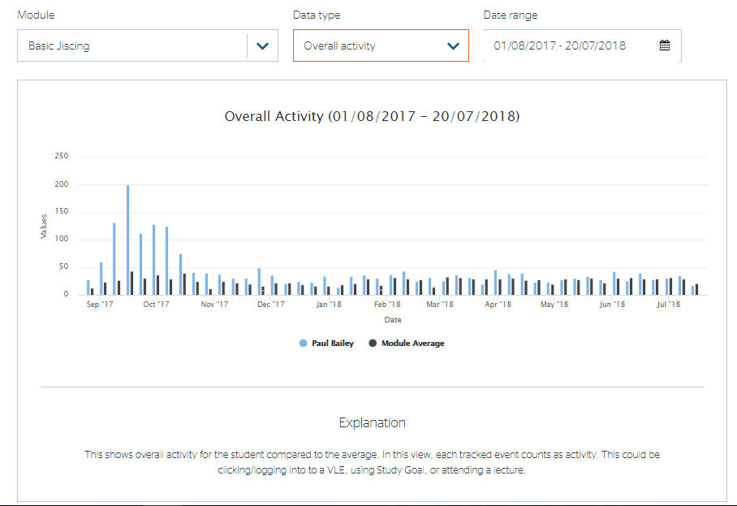
The ‘Module traffic lights’ at the bottom of each ‘Data type’ show RAG status on specific metrics set by your institution level so please contact your project lead for further details.
If you click ‘Show issues’ it will tell you the reasons for any grey, amber or red indicators.
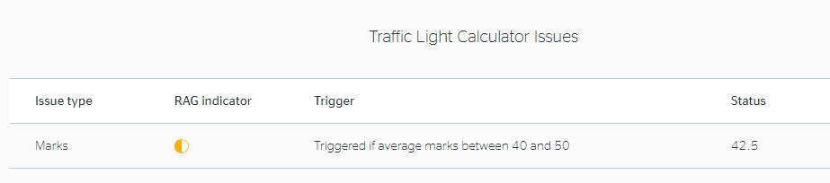

If you click on a module grade you can get further information about the distribution of marks in the module for example.
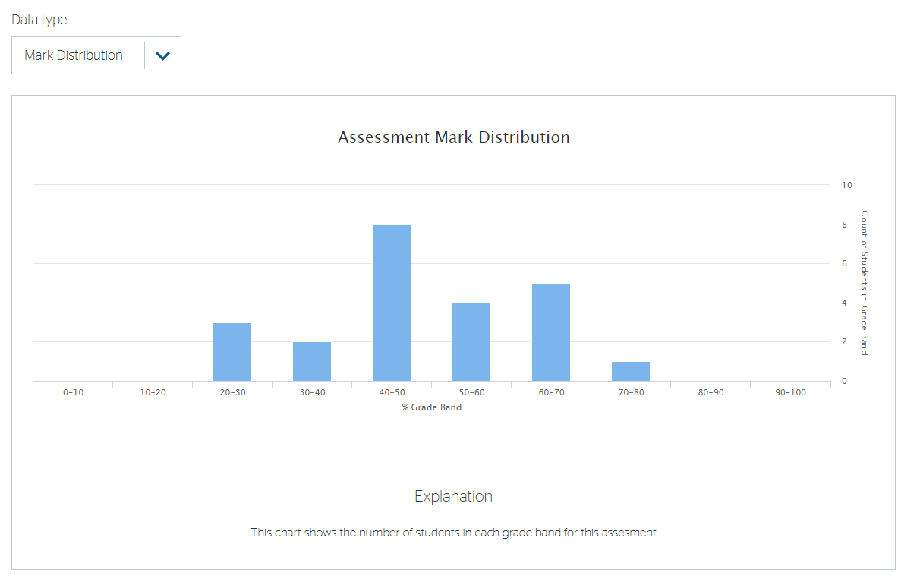

Notes
The notes tab allows the recording of notes and shows a list of any recorded notes of meetings or other interactions with the student.
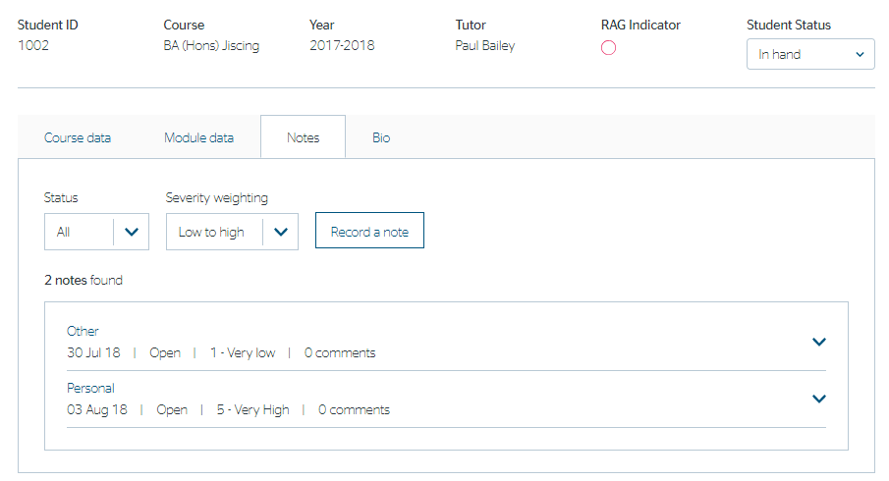
By clicking on ‘Record a note’ you can input details of an intervention with a student.
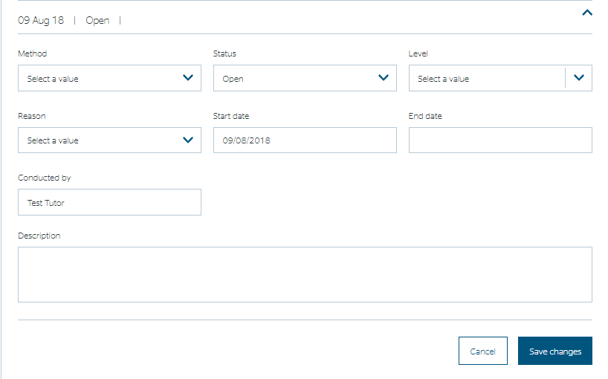

Bio
By clicking on ‘Bio’ you can view other information about the student and also change the student status field.

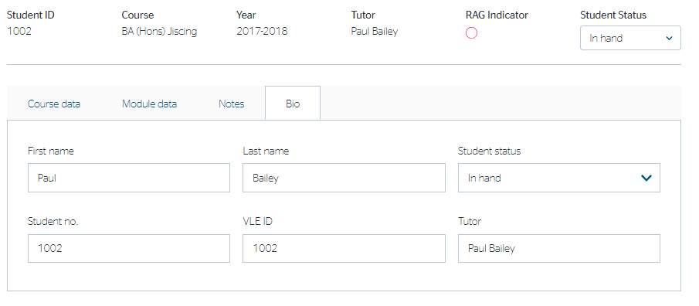

Student Status
You can change the status of a student as ‘in-hand’ or ‘stopped’. The purpose of this is to aid sorting when supporting a larger number of students to focus only on those that aren’t already in hand. This value is set on the student page or in the Bio tab (see above) and then can be used as a filter in views where there a list of students.
Typically, a member of staff would use the filter to view all students who had a ‘Red’ indicator and weren’t already in hand or stopped. Then to review students in-hand to see if their indicators have improved.

My Modules
From ‘My dashboard’ you can select ‘My modules’. You will see a list of the modules you are teaching on/responsible for.
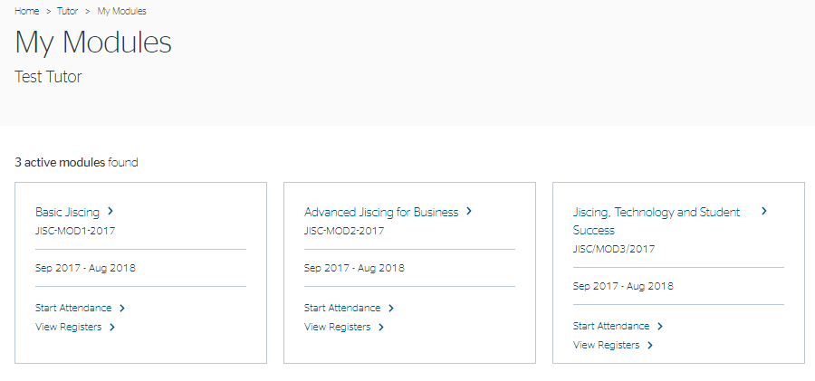

Clicking on the module name will provide you with visualisations of module activity

An explanation is provided for each graph that can be viewed by the Data type menu.
- VLE activity by week/day
- VLE activity – student use distribution
- VLE tool use
- VLE content VLE use vs average mark
- Attendance by event/students
- General indicators -showing assignments associated with the module
- Staff – showing staff associated with the module

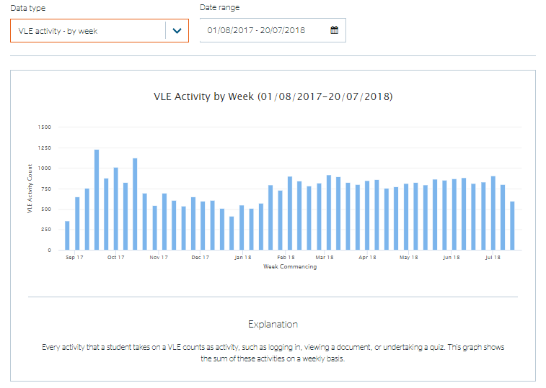

Some of the graphs are interactive i.e. by selecting ‘VLE use Vs average mark’, and clicking on one of the blue dots, you can view that student’s information in more detail.
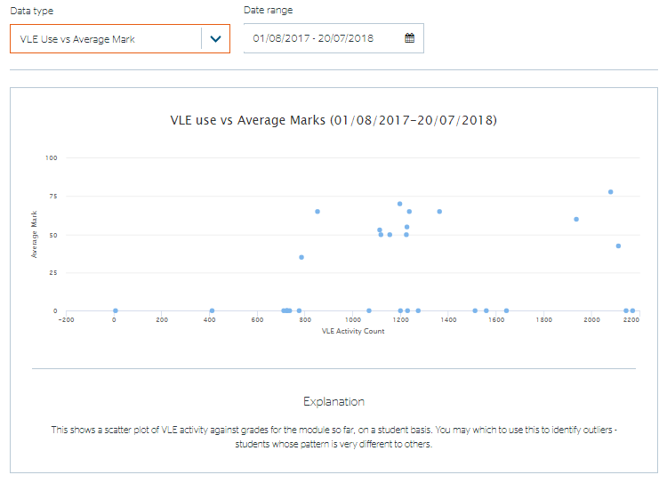

Help Flags
On some page items you will see a help flag, by clicking on the flag will display an explanation.
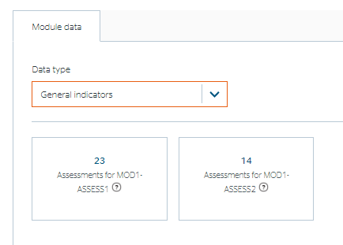
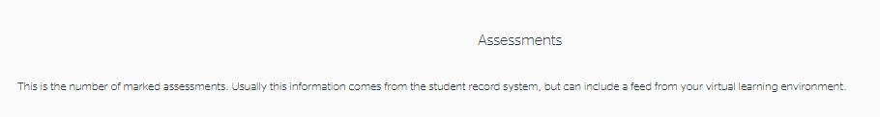

Course Progression data

If it is sent by institutions through the data feed then progression data is available from the ‘Bio’ tab.

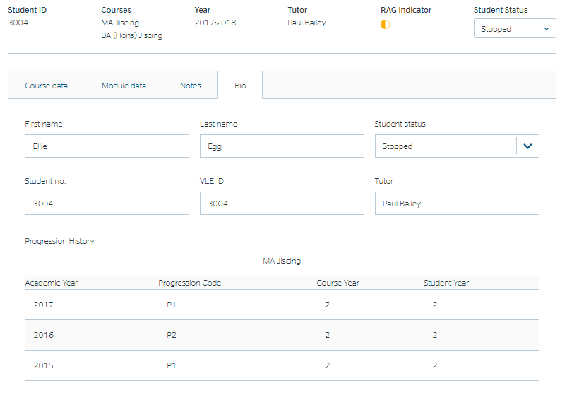

Attendance
If attendance monitoring is enabled, you will see an option next to each module to Start Attendance. This will generate a class list and a 4-digit code (to be used with Study Goal app) which will allow recording of attendance in a session event.
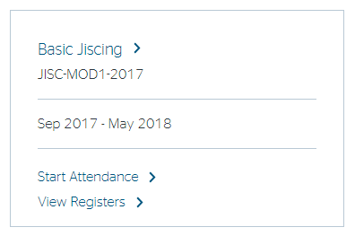

Starting Attendance
When you start a register, you can change the register name, before clicking the Start button..
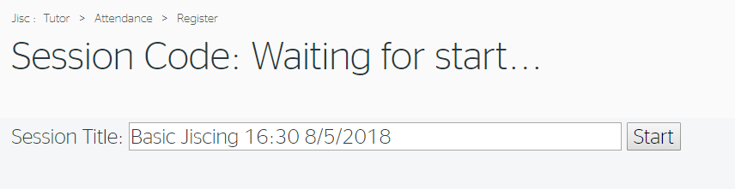

Once the Start button has been clicked, you will see a screen like the one below:
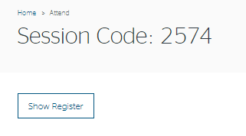
Clicking ‘Show register’ will show the list of students on the module. Students can use the Study goal app to register attendance. Alternatively if students do not have the means to register their attendance and are in attendance you can click on the ‘manual register’ button.

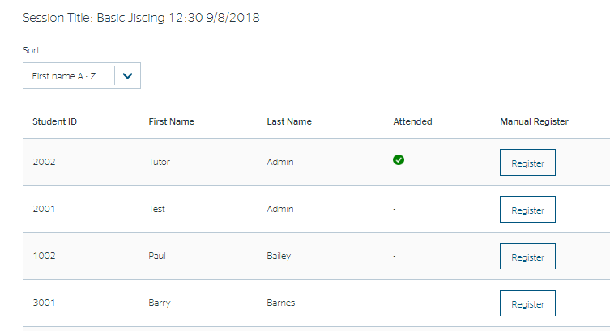
Once a register has been started, the name cannot be changed.
The order or the entries in the register can be changed. Clicking on any of the three grey title boxes will sort them in numerically or alphabetically ascending order for that column.

Viewing Attendance Registers
You can view registers that have previously been recorded in Data Explorer by clicking on “My Modules” and then on the “View Registers” in the row for the module instance of interest.
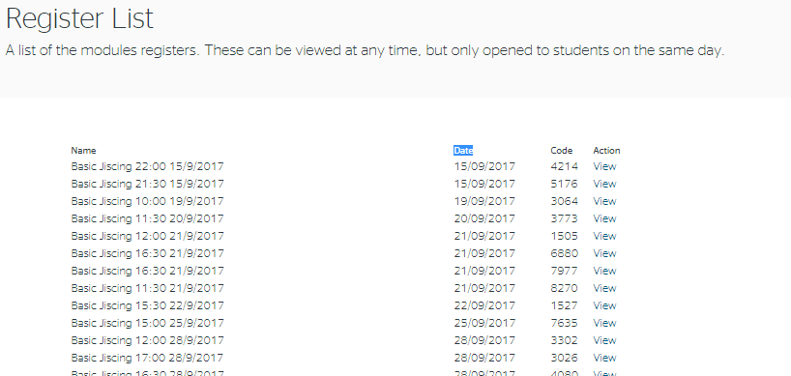

Registers are listed in time order with the earliest listed first. The code can still be used for registers that have an action of ‘Reopen’ against them.

Clicking on ‘Reopen’ will display a screen like the one below:

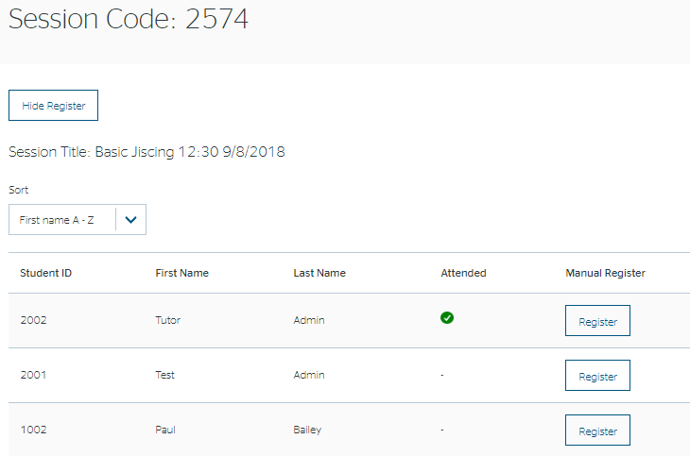

Clicking on the action of ‘View’ against a register will display a screen like the one below. The code cannot now be used by students. However, the tutor can still use the Register button, in both reopened and viewed registers, to record a student’s attendance.
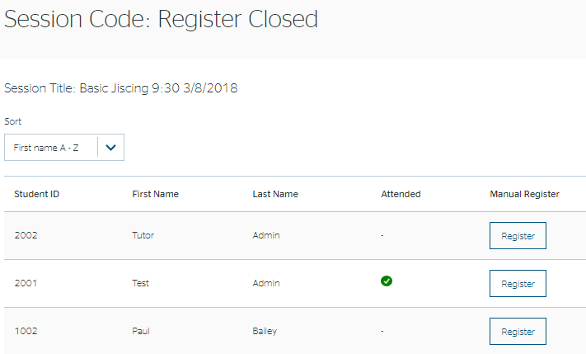

Once registered, students cannot be “unregistered” just like if they scanned their card. A way to deregister students will be explored in the future.

For a full explanation see the Attendance Check-in video at https://docs.analytics.alpha.jisc.ac.uk/docs/study-goal/Home

Help and Advice
Available soon

Providing Feedback or Reporting Faults
If you find a problem with the software or the data, then you should contact your institutional project lead who will collate and report to Jisc via help@jisc.ac.uk

