Data Explorer
Site Explorer Guide version 2.0.2

Overview
Data Explorer is a dashboard interface to allow institutions to view student information as part of the Jisc learning analytics service.
Currently the learning data hub contains information on current students, their modules and assignments (marks). Engagement activity is based on their use of online (VLE) and attendance.

Getting Started
Data Explorer works best in Chrome and is being tested with IE, Safari and Firefox.
To access Data Explorer https://datax.jisc.ac.uk/
The login uses your institutional authentication page, select your institution to login.
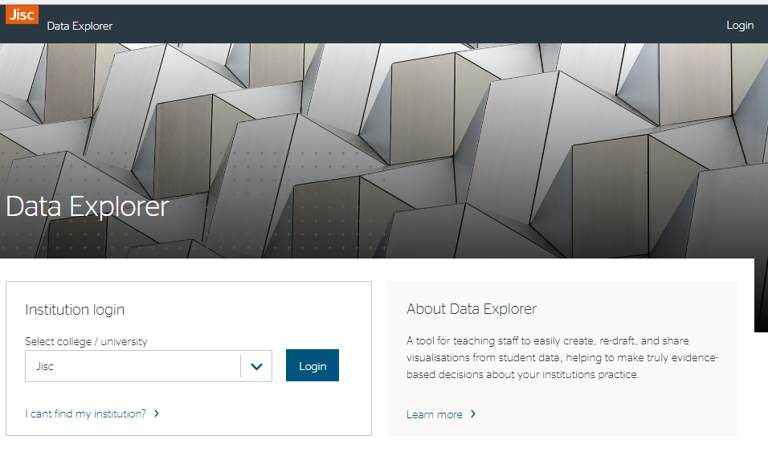

Roles
There are several roles in data explorer that may be assigned to staff.
Tutor role – allows academic staff to see data around the courses and modules they are teaching; and students data if they have an academic tutor group. (This is covered in the Tutor Guide)
Site explorer role – allows staff to see all courses, modules and students they can access, view what a tutor can see and view students at risk (RAG indicator) by faculty, department and course. (or equivalent for your institution)
The site explorer role is designed to be used by staff who have the following roles, for example
- Central services staff who support students and require a global view of students at risk so they can support individual students.
- Faculty/department support staff (e.g. retention officers) who require a view of students at risk so they can support academic staff in supporting individual students.
- Facility/department managers to assess and manage the support of at risk students
- Course leaders to be able to view data for all modules on a course
- Senior tutors to be able to manage and support academic tutors
Site Explorer View
Once you have logged into Data Explorer you will be able to select the tab for Site Explorer view
You can also access the site explorer view from the menu 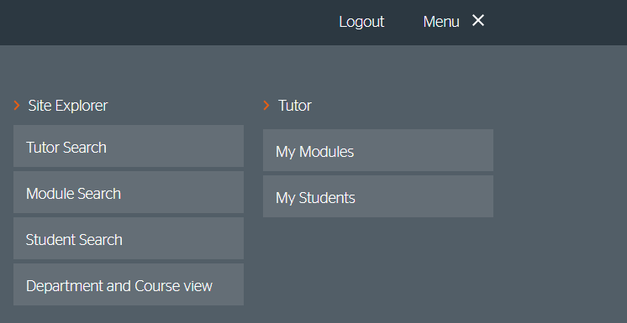
Site explorer gives you the following:
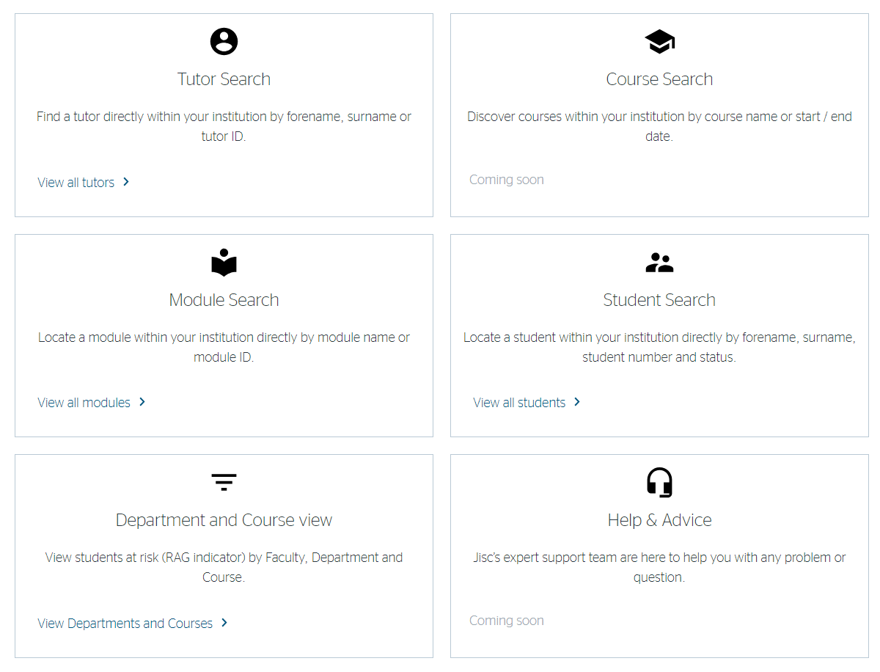

Tutor Search
Allows you to view the student or modules associated with a tutor and see their Tutor View. You can search by list name or an ID. You may use this as a senior tutor reviewing how academic tutor’s groups are getting on or if you are supporting a tutor in teaching a module but don’t actually teach in that module.
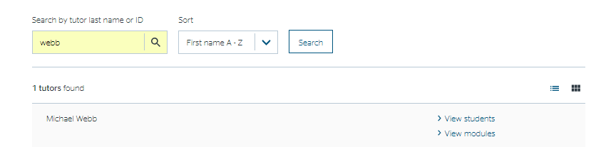

Course Search
Allows you to view all the courses in the institution. You can search by course name, ID or instance ID. By clicking on the name of the course you see more information about that course.
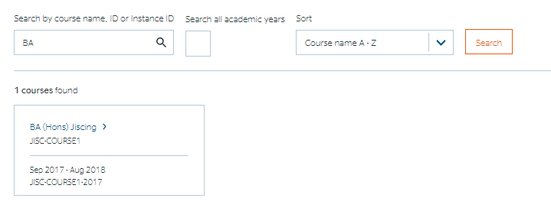

Module Search
Allows you to search for a module and see the same overview a tutor gets.
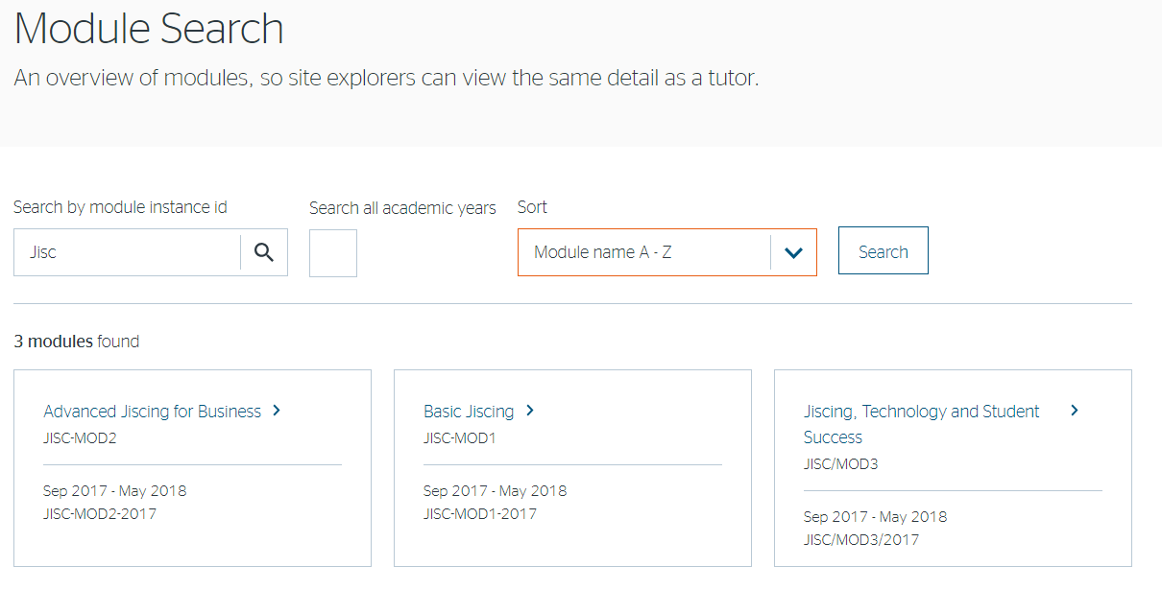
There is a check box that will search for modules from all academic years, otherwise it will just search within the current academic year.
If required the list can be sorted by module name, module id or academic year.

Student Search
You can search for any student by last name or student identifier. The list can be sorted by name, RAG indicator or student identifier. The list can also be filtered by Rag indicator or student status (see below).
Large lists may take time to load.

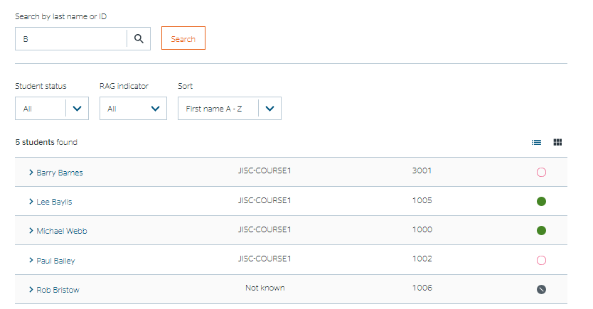

Department and Course View
The terms faculty, department and course may have been configured different in your institutions (e.g. school, programme).
This allows you to view the number of students at risk by department or course, and see a list of students at risk by course.
You start with selecting a faculty.
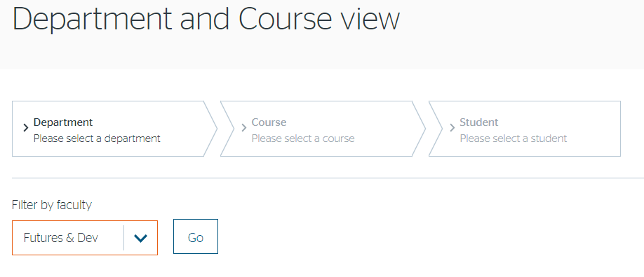
This will give you a list of all departments in the faculty.
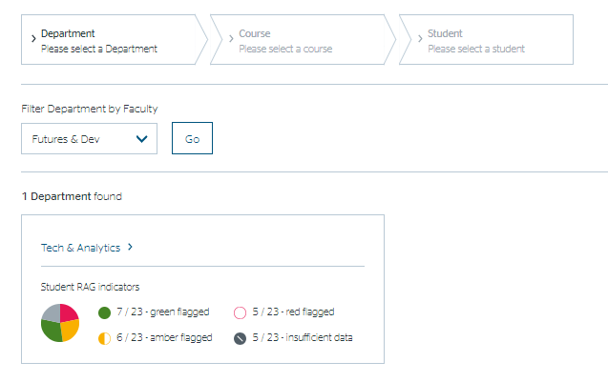
For each department you can see a pie chart and the numerical vales for the number of students with RAG indicators. Red and Amber being at risk students, Green for students below the risk threshold and grey if there is insufficient to calculate risk for any students.
Selecting a department will give you a list of courses, with a similar breakdown.

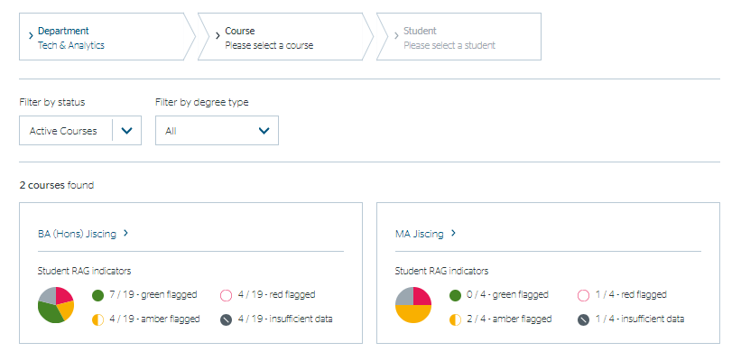
Selecting a course will give you a list of students.

The list can be sorted by name, RAG indicator or student identifier. The list can also be filtered by Rag indicator or student status (see below). 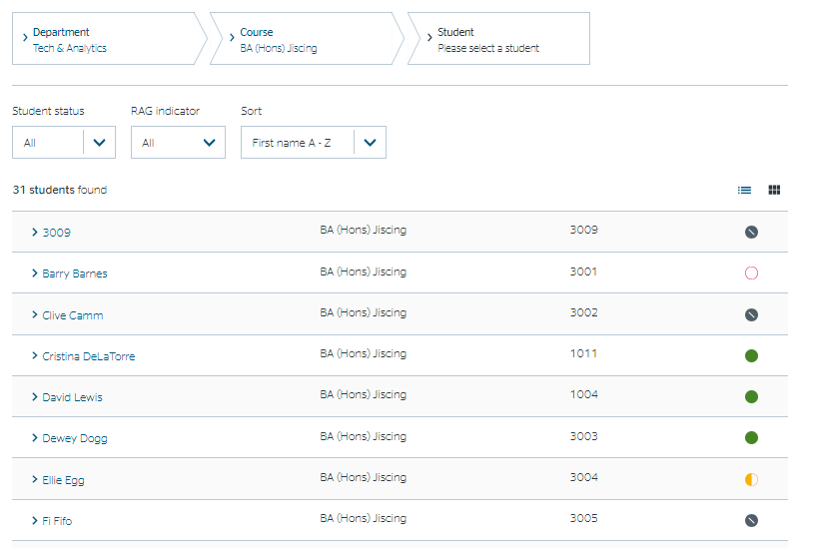
Clicking on the student name will then give you the same student view as can be seen by a tutor.

Help & Advice
More info available soon.

Student Status
You can change the status of a student as ‘in-hand’ or ‘stopped’. The purpose of this is to aid sorting when supporting a larger number of students to focus only on those that aren’t already in hand. This value is set on the student page or in the Bio tab in the student view and then can be used as a filter in views where there a list of students.
Typically, a member of staff would use the filter to view all students who had a ‘Red’ indicator and weren’t already in hand or stopped. Then to review students in-hand to see if their indicators have improved.

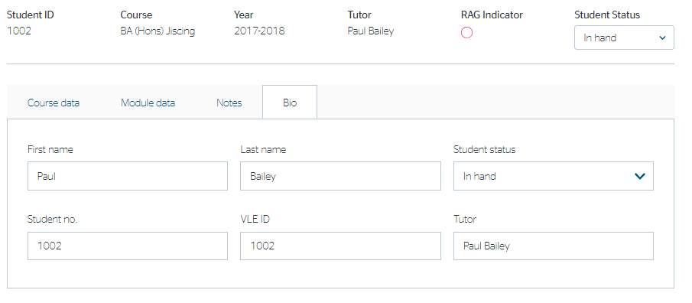

Providing Feedback or Reporting Faults
If you find a problem with the software or the data, then you should contact your institutional project lead who will collate and report to Jisc via help@jisc.ac.uk

