Data Explorer
User Guide version 1.0

Overview

Data Explorer is a dashboard interface to allow institutions to view student information as part of the Jisc learning analytics service. During the beta service (2017-18) further dashboard visualisations will be made available and you are invited to contribute ideas.
Currently the learning data hub contains information on current students, their modules and assignments (marks). Engagement activity is based on their use of online (VLE) and attendance.

Getting Started

Data Explorer works best in Chrome and is being tested with IE, Safari and Firefox.
To access Data Explorer https://x.data.alpha.jisc.ac.uk/
The login uses your institutional authentication page.

Tip
If you have problems loading a screen or waiting for information try
- Reloading the page, that often solves it

Tutor View
Once you have logged into Data Explorer you will see the following Icons
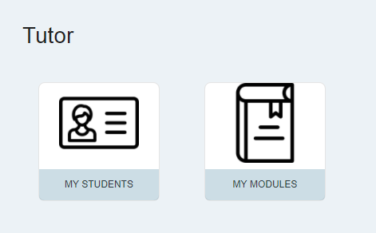

MY STUDENTS
If you select MY STUDENTS you will be able to see a list of all your tutees:
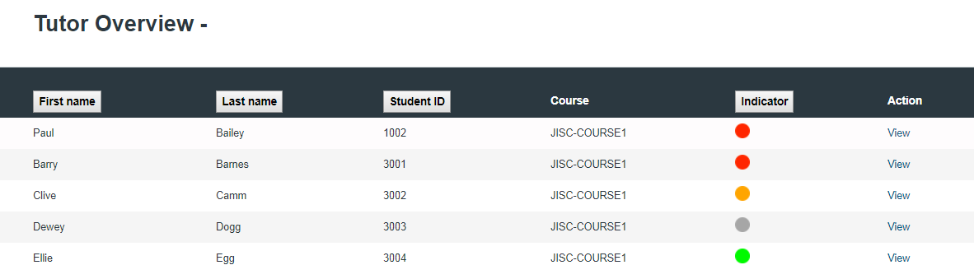
The indicator shows the students risk status and the list can be sorted. Where the Traffic Light Calculator cannot make an assessment, due to lack of data, the indicator on Student Search will be coloured grey.
Clicking on “View” will allow you to see data on an individual student. Moving over the graph will give you more information at particular data points. (Risk predictions are explained below.)
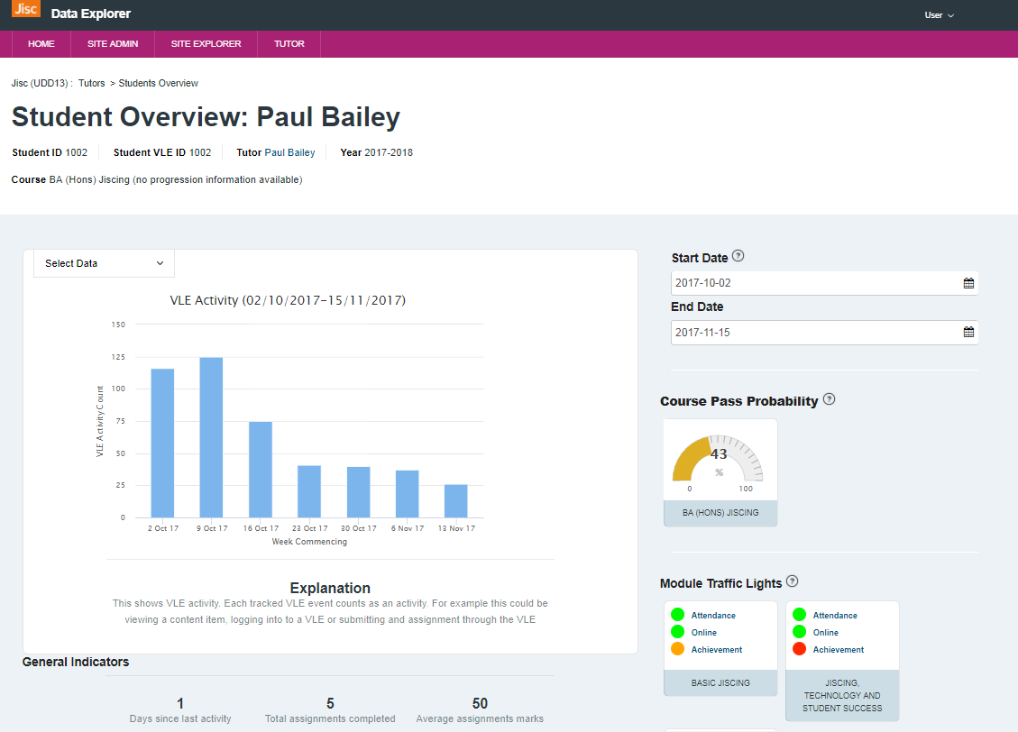

Scrolling down you will also see general indicators for the student overall.
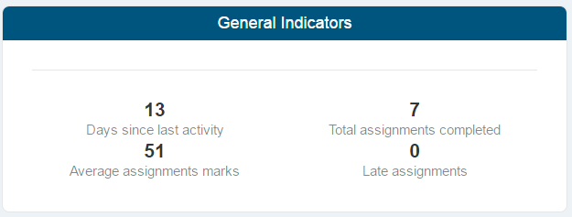

The following visualisations are available,
- VLE Activity
- Overall Activity with Assessment Grades
- Assessment over Time
- Attendance over Time
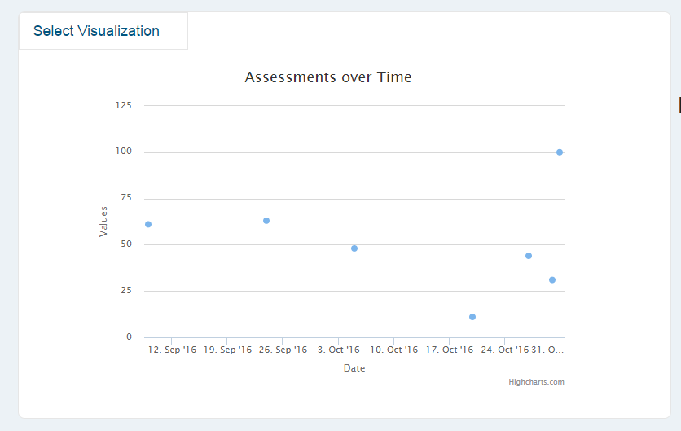

and an explanation is provided on each screen to explain what is on view.
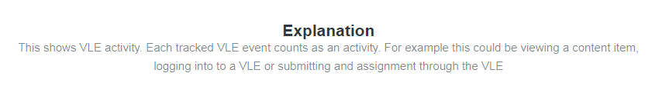

Clicking on the nodes in the “Assessment over time” graph or the flags in the “Overall activity with assessment” graph to obtain more detail about the assessment.

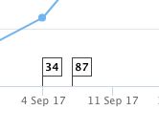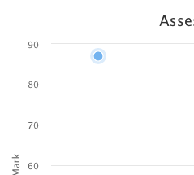

Clicking on these points will display a pop-up:

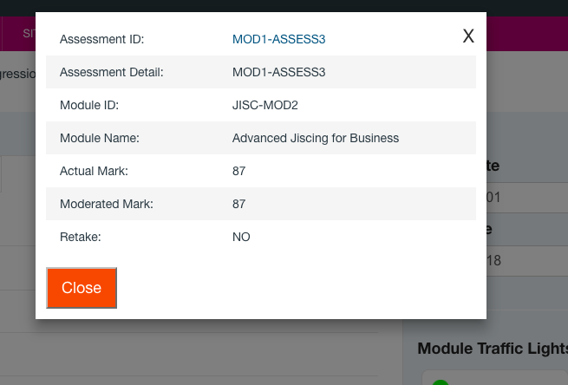

Course Progression data

Is a button is displayed, next to the course name, progression data is available. If not, then the message “no progression information available” will be displayed.

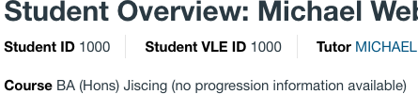

Or

Clicking on the “Show Progression” button will display a pop-up screen:

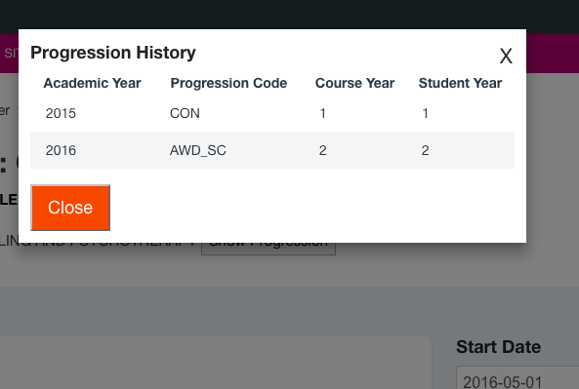

Student Module View and Traffic Light Indicators
You can also view data by module. At present you can see on the right-hand side a list of current and completed modules for a student. If available, you will see Traffic Light Indicators for each module and the latest machine predicted Course Pass Probability as a percentage the student in that course. The lower the percentage the higher the risk of them not passing the course.
The Module Traffic Lights show RAG status on specific metrics set by your institution. See sperate info on the Traffic Light Calculations and below.
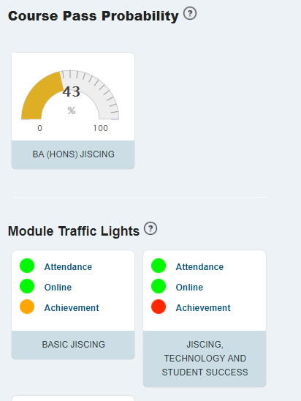
NOTE: The traffic light calculation is set at an institution level so please contact you project lead for further details.
If you click on a module on the right of the student view you can see data specific to that student and module as shown below
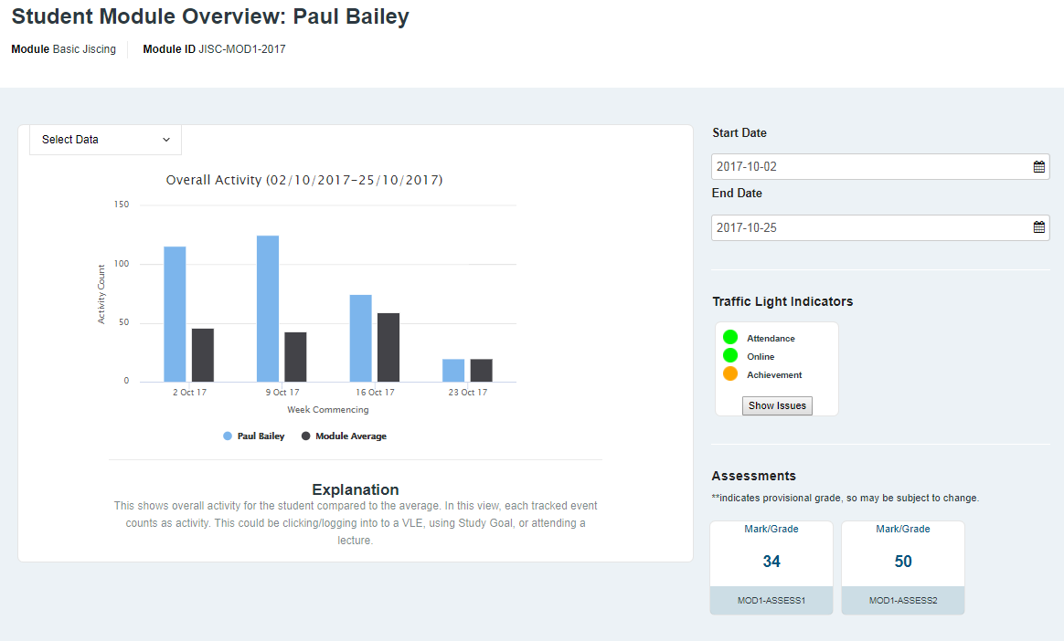
The screen shows indicators for the module and assessments
- Overall Activity – provides a graph of engagement activity by month and average for that module
Further visualisations will be made available in the future. If you have requests or ideas for improvement, please submit these via the feedback form (see below).
If you click show issues it will tell you the reasons for the amber or red indicators
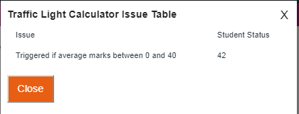

If you click on a module grade you can get further information about the distribution of marks in the module for example.
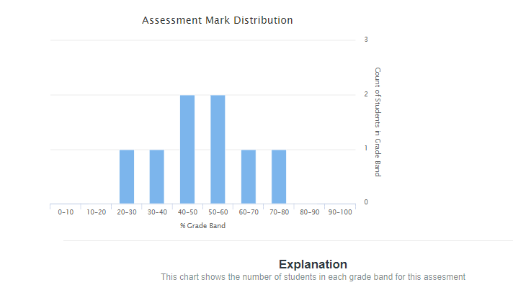

MY MODULES
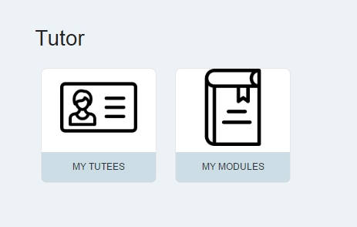
If you select MY MODULES you will see a list of the modules you are teaching on/responsible for.
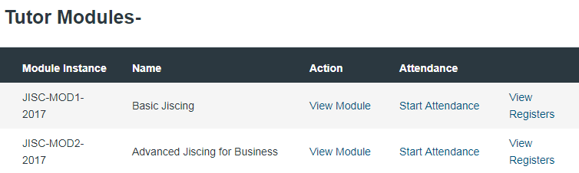
Clicking on “View Module” next to a module name will provide you with visualisations of module activity

You can change the date range, by default this will be the usually be the last 2 months or less
You can see the other staff who are associated with this module.
An explanation is provided for each graph that can be viewed by Select Visualisation menu.

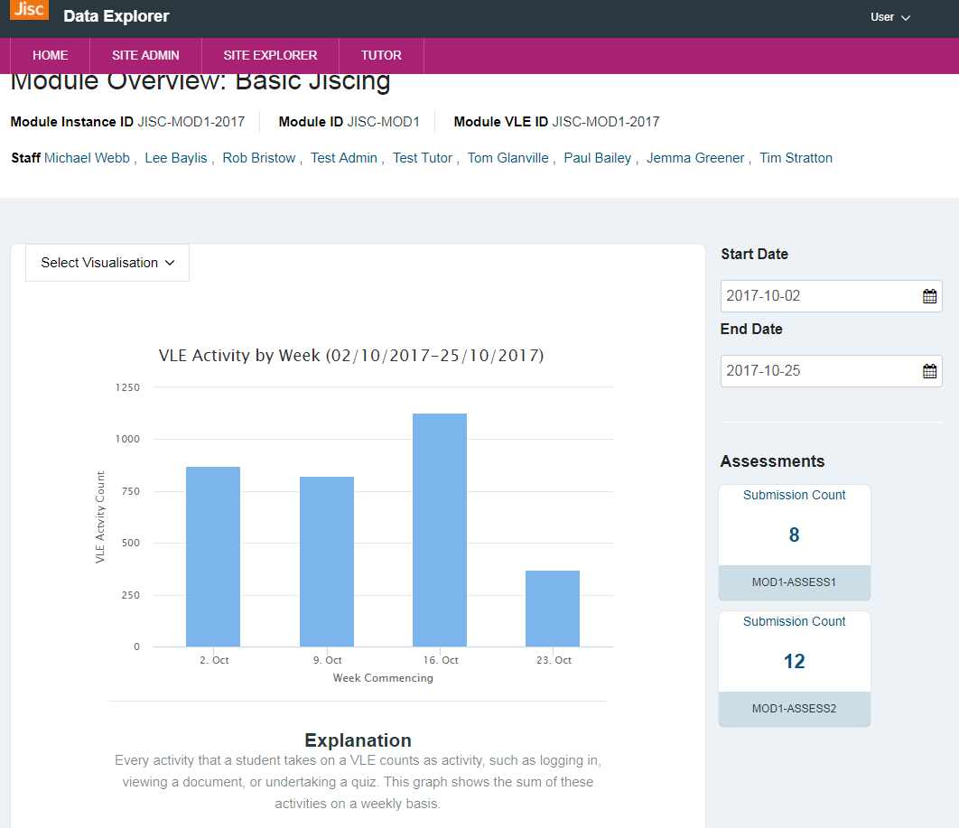
The visualisations menu gives a list of views on the data for the module. These are being developed and improved as we roll-out the beta service.

Some of the graphs are interactive i.e. by clicking on student content use, you can then view which students have accessed the content.

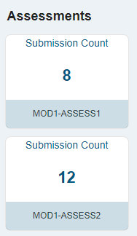 | The module view also provides information on the submission count per assignment in the modules. Clicking on the assessments gives additional graphs

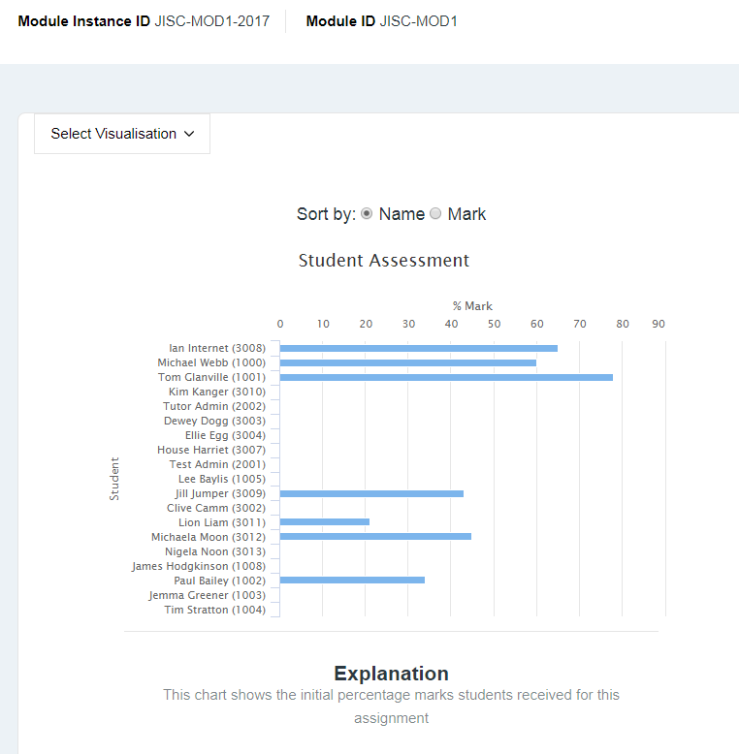

Help flags
On some page items you will see a help flag , clicking on the flag will display an explanation.

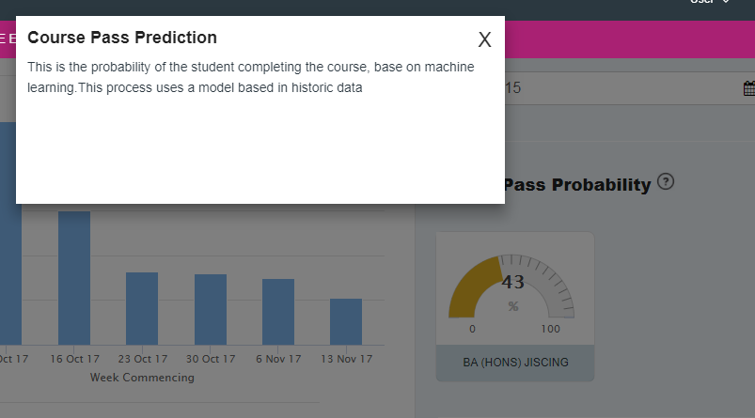

Attendance
If attendance monitoring is enabled, you will see an option next to each module to Start Attendance. This will generate a class list and a 4-digit code (to be used with Study Goal app) which will allow recording of attendance in a session event.
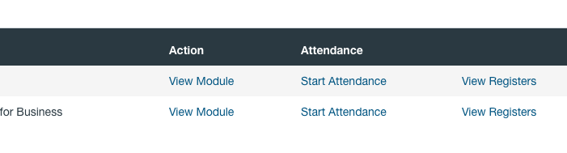

Starting an Attendance Register
When you start a register, you can change the register name, before clicking the Start button..
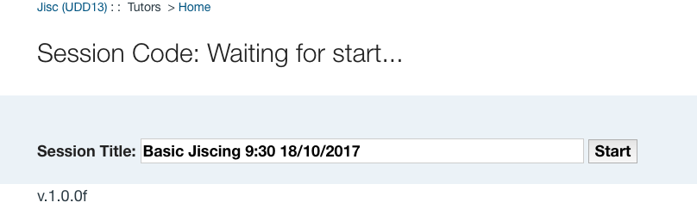
Once the Start button has been clicked, you will see a screen like the one below:

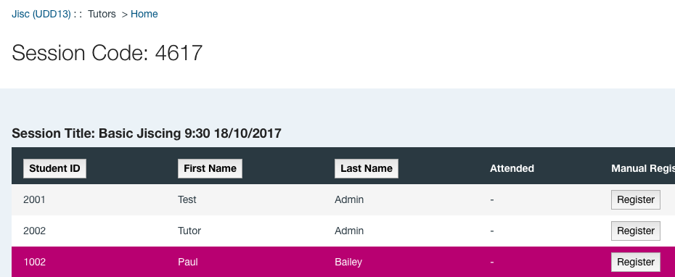
Once a register has been started, the name cannot be changed. Providing this functionality is, again, no straightforward but it’s also good practice not to change the register name once registration entries have been made.
The order or the entries in the register can be changed. Clicking on any of the three grey title boxes will sort them in numerically or alphabetically ascending order for that column.
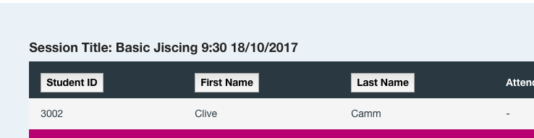

Viewing Attendance Registers
You can view registers that have previously been recorded in Data Explorer by clicking on “My Modules” and then on the “View Registers” in the row for the module instance of interest.

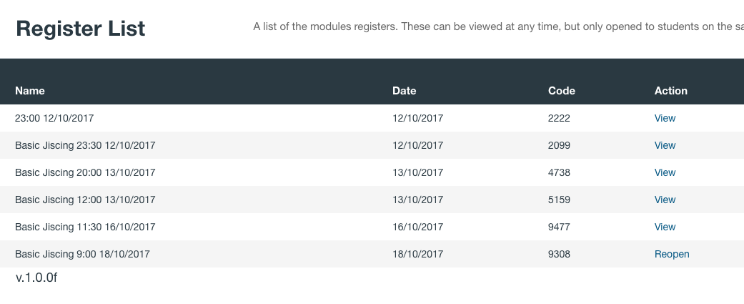
Registers are listed in time order with the earliest listed first. The code can still be used for registers that have an action of “Reopen” against them; clicking on Reopen will display a screen like the one below:
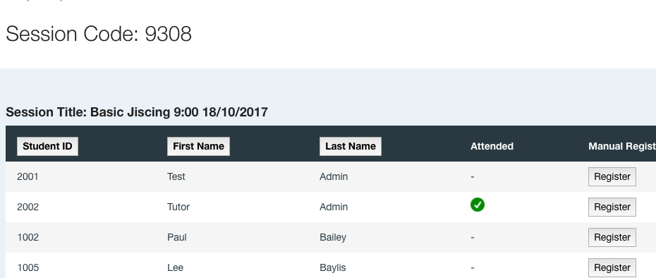

Clicking on the action of “View” against a register will display a screen like the one below. The code cannot now be used by students. However, the tutor can still use the Register button, in both reopened and viewed registers, to record a student’s attendance.

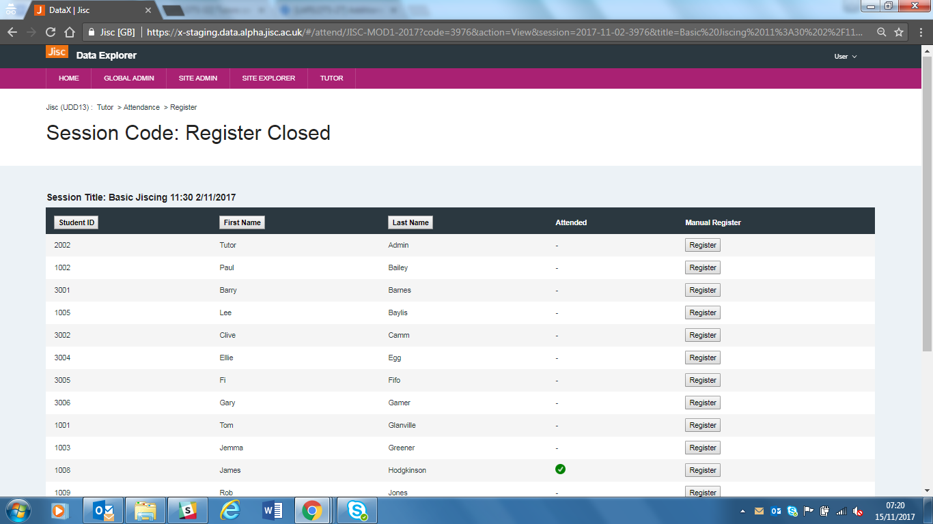

Once registered, students cannot be “unregistered” just like f they scanned their card. A way to deregister students will be explored in the future.

For a full explanation see the Attendance Check-in video at https://docs.analytics.alpha.jisc.ac.uk/docs/study-goal/Home

Providing Feedback or Reporting Faults
If you find a problem with the software or the data then you should contact your institutional project lead who will collate and report to c via our helpdesk.

